**ZenGage Application Notes**

# Version 2.1.0

**Release Date : 23-10-2020**

1. **Configuration file :** Folder structure to be followed
   1. Configuration file\Algo Schema\Default Schema.schema
   2. Configuration file\Algo Schema\Override Schema.schema
   3. Configuration file\Algorithm Parameters\Override\PartName.json
   4. Configuration file\Algorithm Parameters\Default.json
   5. Configuration file\Analytics Parameters.json
   6. Configuration file\DataLogger Parameters.json
   7. Configuration file\JSON and Schema path.json
   8. Configuration file\Machine Interface Parameters.json
   9. Configuration file\MI Opcodes.csv
   10. Configuration file\Rack Controller Parameters Default.json
   11. Configuration file\Rack Controller Parameters Override.json
   12. Configuration file\Software Licence.ini
   13. Configuration file\User Interface.json
   14. Configuration file\User Login Database.csv
   15. Configuration file\ZenCAM v 1.3.1.json
   16. Configuration file\ZenGage Error List.json
   17. Configuration file\Zengage System JSON Override.json
   18. Configuration file\Zengage System Parameters.json
   19. Configuration file\ZenKEY.dll
   20. Configuration file\ZenReport Configuration V2.1.0.json
       1. Should not modify any File/Folder names
       2. Algorithm override files should be created for each part and the file should be saved as per the part name
       3. Measurement names for each part should be configured same in Rack controller configuration file

# Zengage System Parameters :

1. Zentron Logo file path, Customer Logo file path system name and customer name should be added and its used for report generation.
2. Logo file path should be given till the image name and should not mention the image format

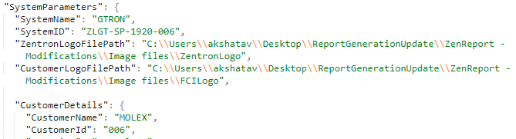

1. ShiftBasedStatisticalData Key to be enable if shift based statistical data to be stored in database
2. To visualize(Data Visualization) offline data on UI 3 parameters to be made as “true”
3. DataLoggingEnable : true
4. DataVisualizationEnable : true
5. MeasurementData : true (from *DataLoggingFeatures*)

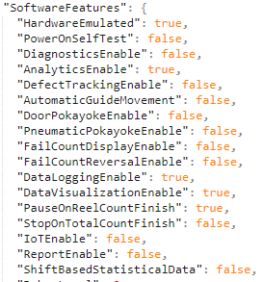

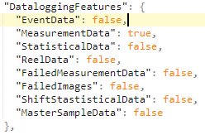

1. EncoderBasedTriggering Key is to be added in PartsConfigured

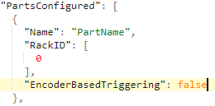

1. **User Interface**
2. Camera names configuration to be done in a same order which is configured in ZenCam JSON.
3. Camera Name should be appended with ( _0 ) and ( _1 ) if same camera is capturing second image

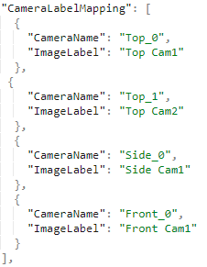

1. **Analytics Parameters**
2. BatchCount to be given a valid number which is used to calculate statistical data for selected batch count value
3. Its used to display Trend and Histogram

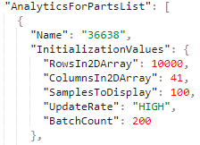

1. GaussianCurveUpdate is used to display distribution curve plot on histogram chart

Note : Min value should be given as **50**

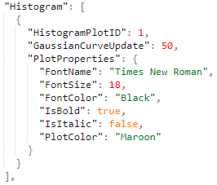

1. FailLegendUpdate is used to display the top most failed measurements on defect chart

for PieChartID : 1 -> the FailLegentUpdate value should be 2 because the sectors are Pass and Fail

For PieChartID : 2 the FailLegendUpdate value can be defined by an user.

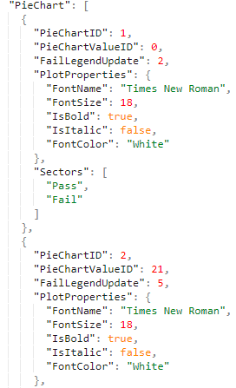

1. **ZenCam - Version 1.3.2**

1. Ensure that **test images** are added inside the ZenCAM folder.

2. Update the following JSON keys

**CameraControllerParameters** :

1. ImageToCamera array in ReceiverSequence:

"DiagnosticsReceiverSequence": {

"ReceiverName": "UI",

"ReceiverID": 0,

**"ImageToCamera": [**

**0**

**]**

}

1. "**PartsList**": [

{

"Name": "36638",

"CameraIDs": [

0,

1,

2

],

"ReceiverSequence": [

{

"ReceiverName": "Algorithm",

"ReceiverID": 0,

**"ImageToCamera": [**

**0,**

**0,**

**1,**

**2**

],

"NoOfActiveCameras": 3

}

]

}

]

**ImageAcquisitionParameters**

1. TimeStamp cluster to be added after Cropping cluster

"TimestampKK": {

"Debug": false,

"TSTest": false,

"TimeDifference": 55,

"UpperToleranceTs": 40,

"LowerToleranceTs": 10,

"MeanUpperTolerancePercentage": 10,

"MeanLowerTolerancePercentage": 10,

"Timestampfilepath": "ZenCAM\\timestamp.csv",

"SwapTestimagefoldername": "Timing analysis\\PerfectSet"

},

**NOTE :**

**ZenReport ToolKit - https://docs.zoho.com/file/m1hs5dc55a5fc75f148bd9cd9db8a14319562**

**After Installing ZenReport replace the library in the following location**

**Library file path : https://docs.zoho.com/file/1e7e2d1b26a7fc277402396f52c33e7c20276**

**Location to be replaced : C:\Program Files (x86)\National Instruments\LabVIEW 2015\vi.lib\Zentron Labs Pvt Ltd\ZenReport**